

AEPES

Semester 2 Examination, 2023

Question/Answer Booklet

Students, please place your name in this box

Time allowed for this paper
Reading time before commencing work: Ten minutes
Working time for paper: Two and a half hours

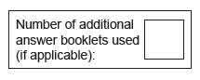
Materials required/recommended for this paper
To be provided by the supervisor
This Question/Answer Booklet
Multiple-Choice Answer Sheet
Extended answer booklet (lined paper)

To be provided by the candidate
Standard items: pens (blue.black preferred), pencils (including coloured), sharpener, correction fluid/tape, eraser, ruler, highlighters
Special items: non-programmable calculators approved for use in the WACE examinations

Important note to candidates
No other items may be taken into the examination room. It is your responsibility to ensure thatyou do not have any unauthorised notes or other items of a non-personal nature in the
examination room. If you have any unauthorised material with you, hand it to the supervisor
before reading any further.

Structure of this paper

Section | Number of  questions  available | Number of  questions to  be answered | Suggested  working time  (minutes) | Marks  available | Percentage  of written  examination
Section One Multiple-choice | 25 | 25 | 30 | 25 | 20%
Section Two  Short answer | 6 | 6 | 90 | 70 | 55%
Section Three Extended answer | 4 | 2 | 60 | 30 | 25%
 |  |  | Total | 125 | 100

Section One: Multiple-choice 20% (25 Marks)

This section has 20 questions. Answer all questions on the Question/Answer booklet. For each question, circle the letter to indicate your answer. Use only a blue or black pen. If you make a mistake, place a cross through that letter, then circle your new answer. Do not erase or use correction fluid/tape. Marks will not be deducted for incorrect answers. No marks will be given if more than one answer is completed for any question.

Suggested working time: 30 minutes.

___________________________________________________________________

- All muscles contain a mixture of muscle fibre types. The main differences between the muscle fibre types are

- speed of extendibility, endurance capacity, force production.
- speed of recovery, dominant energy system, contractual speed.
- excitability, contractibility, elasticity.
- speed of contraction, endurance capacity, force production.

- The long, flat bone located in the centre of the chest is called the

- ribs.
- sternum.
- fibula.
- patella.

- Motor skills can be classified according to specific elements. The athletic event of high jump would be classified as

- gross, discrete, closed
- fine, serial, closed
- gross, serial, closed
- fine, continuous, open

- The local soccer team begin their pre-season training. The coach chooses a relevant method of training that involves continuous running with regular changes of pace according to the natural environment that the team comes across during the session. This method of training is called

- fartlek
- continuous
- plyometrics
- circuit

- Which of the following is not a function of the blood?

- the transportation of nutrients and oxygen
- the regulation of blood pressure
- the regulation of the body’s temperature
- the protection of the body to fight bacteria

- A baseball player strikes the ball in the ‘sweet spot’. The feedback they receive during the strike indicates that it felt successful, this is an example of

- extrinsic, concurrent feedback
- intrinsic, concurrent feedback
- extrinsic, terminal feedback
- intrinsic, terminal feedback

- The small air sacs surrounded by capillaries, which allow oxygen and carbon dioxide to diffuse between the lungs and the blood are called the

- bronchioles
- trachea
- alveoli
- diaphragm

- A tennis player makes a goal to achieve a first serve percentage of 65%. This type of goal is classified as

- an outcome goal
- a process goal
- a realistic goal
- a performance goal

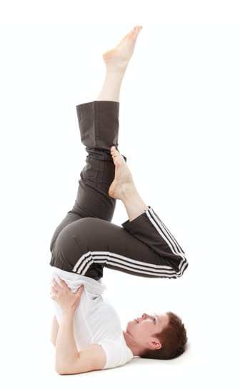
- As the left leg bends in a shoulder stand, the left knee and hip joint experience which movement type?

- extension at the knee and flexion at the hip
- flexion at the knee and rotation at the hip
- flexion at the knee and flexion at the hip
- flexion at the knee and extension at the hip

- A tennis player exerts a force against the ball with the racket, this creates an equal and opposite reaction force. This is example of

- Newton’s First Law of Motion
- Newton’s Second Law of Motion
- Newton’s Third Law of Motion
- Newton’s Fourth Law of Motion

- A rock climber grips the wall, using strength in the hand and fingers as they contract the muscles against an immoveable resistance. This form of resistance training is referred to as
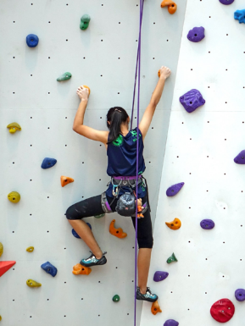
- isometric training
- isotonic training
- isokinetic training
- isolated training

- Which lever system has the force (effort) located between the axis (fulcrum) and resistance (load)?
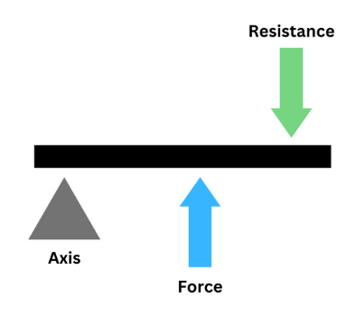
- Second class lever
- Third class lever
- First class lever
- Fourth class lever

- According to the Inverted U Hypothesis, which of the following statements would best describe the relationship between arousal levels and skill complexity?

- higher levels of arousal are required for simple skills
- lower levels of arousal are required for more complex skills
- low levels of arousal are required for simple skills
- both (a) and (b)

- What is the name of the large, flat muscle that is located in the lower part of the trunk, which is worked during pull downs at the gym?

- latissimus dorsi
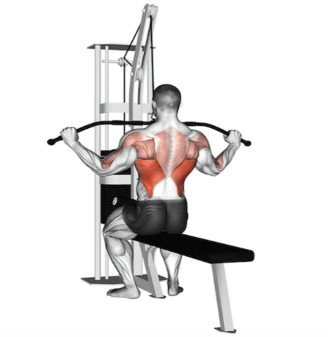
- trapezius
- adductor group
- deltoids

- The range of a projectile is dependent on three key factors. These are

- acceleration of release, height of release, trajectory of release
- height of release, angle of release, accuracy of release
- angle of release, power of release, speed of release
- height of release, angle of release, velocity of release

- Which of the following terms best describes the ability of a muscle to respond to a stimulus?

- elasticity
- contractibility
- extensibility
- excitability

- Which chamber of the heart is responsible for pumping oxygenated blood through the aorta for distribution to the rest of the body?

- left atrium
- left ventricle
- right ventricle
- right atrium

- Components of fitness can be categorised in terms of health related and performance related. Which of the following would be consider health related components?

- coordination, flexibility, power
- cardiorespiratory endurance, body composition, speed
- body composition, muscular strength, muscular endurance
- flexibility, balance, reaction time

- The coach provides Jamie with the following feedback, “Much better Jamie! You held your wrist firm during the stroke and your follow-through directed the ball down the line.” What was the purpose of giving this specific feedback?

- motivation and reinforcement
- motivation and praise
- reinforcement and correction of errors
- verbal and extrinsic

- Which of the following is the true definition of the origin and insertion points of muscle attachment?

- the origin is where the muscle joins to the stationary bone. The insertion is the point where the muscle is attached to the next stationary bone
- the origin is where the muscle joins to the stationary bone. The insertion is the point where the muscle is attached to the moving bone
- the origin is where the muscle joins to the moving bone. The insertion is the point where the muscle is attached to the stationary bone
- the origin is where the muscle joins to the moving bone. The insertion is the point where the muscle is attached to the next moving bone

- High Glycaemic Index (GI) food sources are most appropriate for athletes to:

        - provide muscles with a rapid source of energy immediately prior and during competition.
        - increase glycogen stores in the muscle and liver.
        - improve efficiency of the aerobic energy system during short intervals.
        - provide muscles with a sustained release of energy during competition.

- In golf, the pin (hole) can be higher than the tee off shot. Which angle of projection would seem the most accurate for a tee off shot in this circumstance?

- 20 degrees.
- 45 degrees.
- 65 degrees.
- 90 degrees.

- Which of the following statements about arousal is correct?

- Boxing requires a high level of arousal for optimal performance.
- Novice performers require a high level of arousal for optimal performance.
- Archery requires a high level of arousal for optimal performance.
- Cliff top diving requires a high level of arousal for optimal performance.

- A cricket batsman observing the position of the ball in the bowler’s hand and type of release would be at which phase of the Information Processing Model?

        - Identification of stimulus / input phase.
        - Response identification/decision-making phase.
        - Response/output phase.
        - Feedback phase.

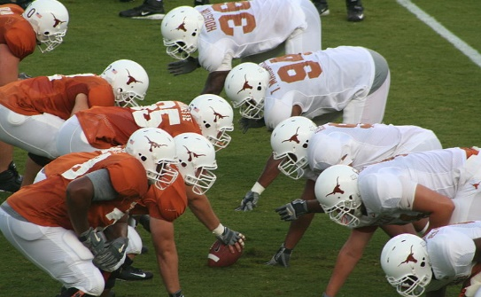
- In American gridiron, the offensive linesman position themselves to protect their quarterback by stabilising themselves to withstand the defenders tackle.

Which of the following would improve their balance and stability?

  - Lower their centre of mass, line of gravity over base of support, increase points of contact.
  - Raise their centre of mass, line of gravity over base of support, increase points of contact.
  - Lower their centre of mass, line of gravity outside base of support, increase points of contact.
  - Lower their centre of mass, line of gravity over base of support, decrease points of contact.
End of Section One
Section Two: Short answer % (70 Marks)

This section has six questions. Answer all questions. Write your answers in the spaces provided. Supplementary pages for planning/continuing your answers to questions are provided at the end of this Question/Answer booklet. If you use these pages to continue an answer, indicate at the original answer where the answer is continued, i.e. give the page number.

Suggested working time: 90 minutes.

___________________________________________________________________

Question 26 (9 marks)

The body has a number of important and essential systems that work together to maintain health and promote optimal sports performance.

- Explain the main function of the circulatory system (2 marks)

______________________________________________________________________________________________________________________________________

- The heart plays a central role in the functioning of the circulatory system. Identify the type of muscle the heart is classified as. (1 mark)

___________________________________________________________________

- There are three main blood vessels that make up the vascular system. Name the three types and state one function of each. (6 marks)

_________________________________________________________________________________________________________________________________________________________________________________________________________________________________________________________________________________________________________________________________________________________________________________________________________________

Question 27 (12 marks)

The Fitts and Posner phases of motor learning can be applied by coaches and performers as they move through the continuum of learning a new motor skill.

- Name the three phases of learning according to Fitts and Posner. (3 marks)

_________________________________________________________________________________________________________________________________________________________________________________________________________

- A volleyball player is
- beginning to take cues from the external environment
- starting to eliminate large errors
- focusing practice on timing and sequencing of whole skills
- placing greater emphasis on internal feedback.

Identify the phase of learning this volleyball player is currently in and outline two characteristics of performance that would move them towards a higher level of learning. (3 marks)
_________________________________________________________________________________________________________________________________________________________________________________________________________
___________________________________________________________________

- A beginner would require more cues to improve their current level of skill performance than a more seasoned player. Name three types of cues that a coach could provide during a training session and provide an example for each.
(6 marks)

_________________________________________________________________________________________________________________________________________________________________________________________________________
_________________________________________________________________________________________________________________________________________________________________________________________________________

Question 28 (6 marks)

The marathon is an endurance event run over a distance of 42.2km. Elite athletes will take between 2 - 2½ hours to complete the distance.

In order to compete for 2 - 2½ hours at optimal performance, athletes must consider their nutritional requirements prior to competition. Describe how a marathon runner would utilise their different energy sources to fuel themselves throughout the race.

______________________________________________________________________________________________________________________________________
______________________________________________________________________________________________________________________________________
______________________________________________________________________________________________________________________________________
______________________________________________________________________________________________________________________________________
___________________________________________________________________
Question 29 (4 marks)

The bicep curl is a common exercise utilised by weightlifters to gain strength.

- Using your understanding of levers, label the components of the lever shown in the bicep curl below: (3 marks)

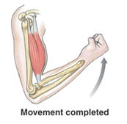

- Identify the class of lever you have labelled. (1 mark)

Question 30 (10 marks)

Jess is a 1500m runner, who is currently working to improve the efficiency of the energy systems throughout the duration of the race.

- The graph below represents the continuum of the three energy systems to provide ATP at the start of the race. Identify each energy system on the graph. (3 marks)

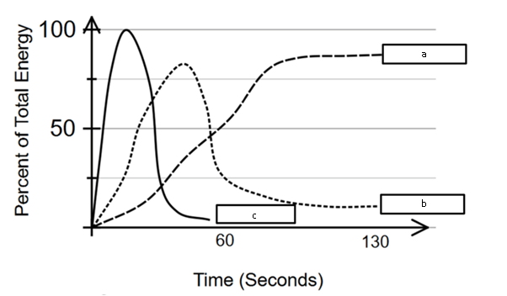

a ______________________________________________________________
b ______________________________________________________________
c ______________________________________________________________

- Jess holds a personal best time of 4 minutes 42 seconds. Identify the energy system which would contribute the most to energy production in the latter parts of the race. Justify your answer by comparing the contribution of each energy system. (4 marks)

______________________________________________________________________________________________________________________________________
______________________________________________________________________________________________________________________________________
______________________________________________________________________________________________________________________________________
Question 26 (13 marks)

Javelin is a demanding, explosive throwing event which combines strength, speed, power and flexibility to maximise the distance of the throw.

- At the start of a training session, an athlete begins their warmup with some gentle dynamic movements in the upper body. Label the movement types shown by the arrows below (figure 1a) The athlete moves the arm up and down (a and b) and in a circular motion (c). (3 marks)

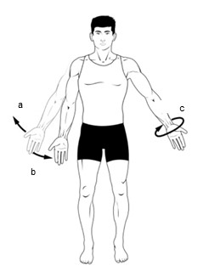

- The coach sets up a specific number of exercise stations and the athletes complete each station consecutively according to a set work/recovery ratio. Name the type of training method the coach is implementing for the athletes. (1 mark)

___________________________________________________________________

- To optimise flight time and distance thrown, throwers can refer to the principle of optimal projection. Explain the optimal angle of release the athlete should consider to maximise flight time and increase distance thrown. (2 marks)

______________________________________________________________________________________________________________________________________
______________________________________________________________________________________________________________________________________

- Goal setting is a priority for any elite performer to ensure that all training is focused towards achieving a specific result. Goal setting often follows a set of characteristics. Outline the seven characteristics of goals the javelin throwers could use to write effective goals. (7 marks)

______________________________________________________________________________________________________________________________________
______________________________________________________________________________________________________________________________________
______________________________________________________________________________________________________________________________________
______________________________________________________________________________________________________________________________________
___________________________________________________________________
______________________________________________________________________________________________________________________________________
___________________________________________________________________
___________________________________________________________________

Question 27 (15 marks)

An aspiring boxer has enlisted the help of a professional performance coach in the hope of improving his physiological capacity and overall performance.

- Identify and explain two training principles that this coach could use to achieve optimal performance results for the boxer. (6 marks)

______________________________________________________________________________________________________________________________________
______________________________________________________________________________________________________________________________________
______________________________________________________________________________________________________________________________________

- The boxer often uses a weighted punch bag which hangs from the roof of the gym. State Newton’s First Law of Motion and explain how this law could be applied to the punch bag as the boxer throws his first punch. (3 marks)

______________________________________________________________________________________________________________________________________
___________________________________________________________________

- As the boxer begins his training session his heart rate and respiratory rate start to increase in response to the rising energy and exertion demands on the body. Identify two other immediate physiological responses the boxer may experience with the onset of exercise and describe why each of these occur. (6 marks)

______________________________________________________________________________________________________________________________________
______________________________________________________________________________________________________________________________________
______________________________________________________________________________________________________________________________________

Question (5 marks)

- Nideffer’s Model of Attention identifies four possible types of attentional focus.
Label the figure below. (3 marks)

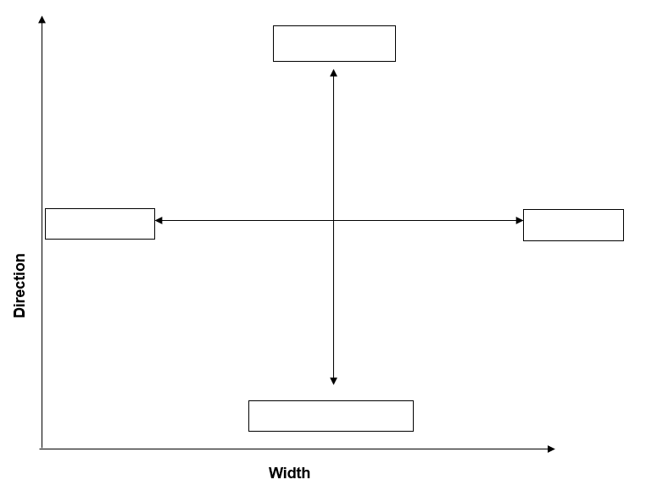
External

- Name where Basketball would belong on the model and justify your response.
(2 marks)

______________________________________________________________________________________________________________________________________
______________________________________________________________________________________________________________________________________

End of Section Two
Section Three: Extended answer 30% (30 Marks)

This section contains four questions. You must answer two questions. Write your answers in the spaces provided. Supplementary pages for planning/continuing your answers to questions are provided at the end of this Question/Answer booklet. If you use these pages to continue an answer, indicate at the original answer where the answer is continued, i.e. give the page number.

Suggested working time: 60 minutes.

___________________________________________________________________

Question 27 (15 marks)

A goalkeeper prepares himself physically and mentally for an incoming penalty. He skilfully processes the information available to give himself the best possible chance of a successful save.

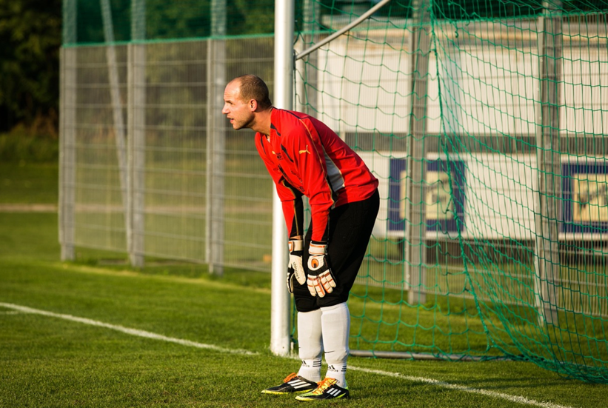

- The information processing model is one example used to consider how learning and execution of a skilled performance takes place. Identify and outline each stage of the information processing model. Apply each stage of the model to the goalkeeper attempting to save the penalty. (12 marks)

______________________________________________________________________________________________________________________________________
______________________________________________________________________________________________________________________________________
______________________________________________________________________________________________________________________________________
______________________________________________________________________________________________________________________________________
______________________________________________________________________________________________________________________________________
______________________________________________________________________________________________________________________________________
______________________________________________________________________________________________________________________________________
______________________________________________________________________________________________________________________________________
______________________________________________________________________________________________________________________________________
______________________________________________________________________________________________________________________________________
______________________________________________________________________________________________________________________________________
______________________________________________________________________________________________________________________________________
______________________________________________________________________________________________________________________________________
______________________________________________________________________________________________________________________________________
______________________________________________________________________________________________________________________________________

- The soccer player below prepares to take a penalty kick. He is aiming to drive the ball fast and hard into the bottom right-hand corner of the net. Define Newton’s Second Law of Motion and explain how the application of this law could assist the soccer player in achieving his objective and make it more difficult for the goalkeeper to save. (3 marks)

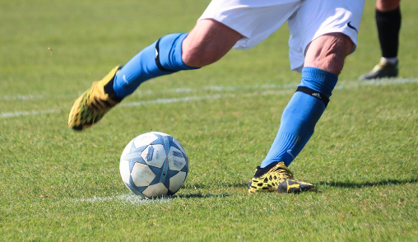

______________________________________________________________________________________________________________________________________
______________________________________________________________________________________________________________________________________
______________________________________________________________________________________________________________________________________

Question 28 (15 marks)

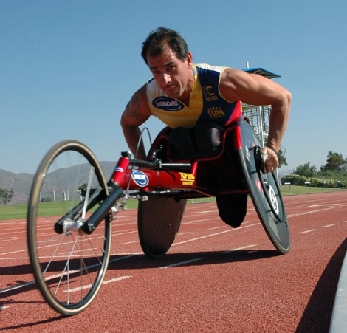
A wheelchair athlete uses their race data to evaluate speed, velocity, and acceleration over different phases of the race.

- Identify and outline the type of motion a wheelchair athlete would demonstrate during a race. Explain how the athlete can use race data relating to speed and acceleration during a 1500m race (approximately three and a half minutes). (5 marks)

______________________________________________________________________________________________________________________________________
______________________________________________________________________________________________________________________________________
______________________________________________________________________________________________________________________________________
The rigorous training program followed by the wheelchair athlete creates long-term physiological adaptations in the body, which continue to improve performance levels over time. The athlete may observe a gradual increase in stroke volume in addition to other long-term adaptations.

- Explain how an increase in stroke volume will assist the performance of the wheelchair athlete. In addition, name and outline two other cardiovascular effects and two respiratory effects that long-term training may have on the athlete. (10 marks)

______________________________________________________________________________________________________________________________________
______________________________________________________________________________________________________________________________________
______________________________________________________________________________________________________________________________________
______________________________________________________________________________________________________________________________________
______________________________________________________________________________________________________________________________________
______________________________________________________________________________________________________________________________________
______________________________________________________________________________________________________________________________________
______________________________________________________________________________________________________________________________________
______________________________________________________________________________________________________________________________________
_________________________________________________________________________________________________________________________________________________________________________________________________________________________________________________________________________________________________________________________________________________________________________________________________________________________________________________________________________________________________________________________________________________________________________________________________________________________________________________________________________________________________________________________________________________________________
Question 29 (15 marks)

British tour cyclist Tao Geoghegan Hart is preparing to take the start line at one of the most challenging races on the tour, the Giro d'Italia (21 stages/total of 3,489.2km). After taking the title in 2020, Geoghegan Hart has been plagued with injury and illness, but despite these challenges a recent sports report stated that the 28-year-old Londoner has every reason to feel confident. (Hurcom, BBC Sport, 5 May 2023).

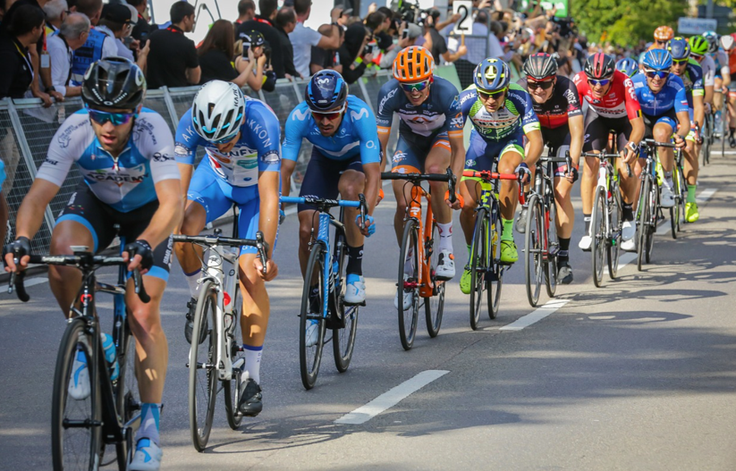

- Define self-confidence and outline a reason why optimising self-confidence is beneficial to performance outcomes. To remain confident Tao would need to consistently work on his motivation levels as he strived to overcome his challenges. Name and outline two types of motivation and explain how each can be applied to Tao. (10 marks)
______________________________________________________________________________________________________________________________________
______________________________________________________________________________________________________________________________________
______________________________________________________________________________________________________________________________________
______________________________________________________________________________________________________________________________________
______________________________________________________________________________________________________________________________________
______________________________________________________________________________________________________________________________________
______________________________________________________________________________________________________________________________________
______________________________________________________________________________________________________________________________________
______________________________________________________________________________________________________________________________________
______________________________________________________________________________________________________________________________________
______________________________________________________________________________________________________________________________________
______________________________________________________________________________________________________________________________________

- Tour cycling requires training specific components of fitness such as cardiorespiratory endurance. Define this component and identify two additional components of fitness that would be required in the sport of road racing. For each additional component, outline why this component would be important. (5 marks)

______________________________________________________________________________________________________________________________________
______________________________________________________________________________________________________________________________________
______________________________________________________________________________________________________________________________________
______________________________________________________________________________________________________________________________________

Question 30 (15 marks)

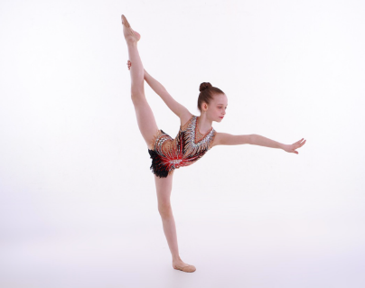
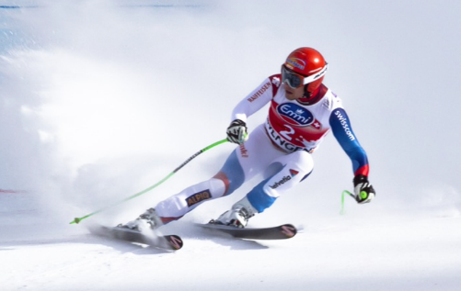
Image 1
Image 2

The images above show a gymnast (image 1) and a downhill skier (image 2), both skilfully managing to manipulate balance in their respective events.

- Define the term balance and identify the type of balance the gymnast (image 1) and the downhill skier (image 2) are demonstrating. If mass is consistent, name and explain how each athlete uses these factors to ensure success in their respective events. (10 marks)

______________________________________________________________________________________________________________________________________
______________________________________________________________________________________________________________________________________
______________________________________________________________________________________________________________________________________
______________________________________________________________________________________________________________________________________
______________________________________________________________________________________________________________________________________
______________________________________________________________________________________________________________________________________
______________________________________________________________________________________________________________________________________
______________________________________________________________________________________________________________________________________
______________________________________________________________________________________________________________________________________
______________________________________________________________________________________________________________________________________
______________________________________________________________________________________________________________________________________
______________________________________________________________________________________________________________________________________
______________________________________________________________________________________________________________________________________
______________________________________________________________________________________________________________________________________
______________________________________________________________________________________________________________________________________
______________________________________________________________________________________________________________________________________
- To help the gymnast overcome nerves before the start of her gymnastic routine her coach encourages her to do some diaphragmatic breathing and take a long slow exhale. Outline what the diaphragm is and explain how air is pushed out of the lungs through the process of expiration (exhalation). (5 marks)

______________________________________________________________________________________________________________________________________
______________________________________________________________________________________________________________________________________
______________________________________________________________________________________________________________________________________

End of questions
Supplementary page

Question number: ___________________

____________________________________________________________________________________________________________________________________________________________________________________________________________________________________________________________________________
____________________________________________________________________________________________________________________________________________________________________________________________________________________________________________________________________________
____________________________________________________________________________________________________________________________________________________________________________________________________________________________________________________________________________
____________________________________________________________________________________________________________________________________________________________________________________________________________________________________________________________________________
____________________________________________________________________________________________________________________________________________________________________________________________________________________________________________________________________________
______________________________________________________________________________________________________________________________________

Supplementary page

Question number: ___________________

____________________________________________________________________________________________________________________________________________________________________________________________________________________________________________________________________________
____________________________________________________________________________________________________________________________________________________________________________________________________________________________________________________________________________
____________________________________________________________________________________________________________________________________________________________________________________________________________________________________________________________________________
____________________________________________________________________________________________________________________________________________________________________________________________________________________________________________________________________________
____________________________________________________________________________________________________________________________________________________________________________________________________________________________________________________________________________

Supplementary page

Question number: ___________________

____________________________________________________________________________________________________________________________________________________________________________________________________________________________________________________________________________
____________________________________________________________________________________________________________________________________________________________________________________________________________________________________________________________________________
____________________________________________________________________________________________________________________________________________________________________________________________________________________________________________________________________________
____________________________________________________________________________________________________________________________________________________________________________________________________________________________________________________________________________
____________________________________________________________________________________________________________________________________________________________________________________________________________________________________________________________________________
______________________________________________________________________________________________________________________________________

ACKNOWLEDGEMENTS

Question Number Source

9 https://pixabay.com/photos/aerobics-balance-exercise-female-18884/

11 https://pixabay.com/photos/climbing-rope-rappelling-wall-rock-480459/

14 https://parallelcoaching.co.uk/lat-pull-down-technique-how-to-correct-a-client

23 https://stock.adobe.com/au/search?filters%5Bcontent_type%3Aphoto%5D=1&filters%5Bcontent_type%3Aillustration%5D=1&filters%5Bcontent_type%3Azip_vector%5D=1&filters%5Bcontent_type%3Avideo%5D=1&filters%5Bcontent_type%3Atemplate%5D=1&filters%5Bcontent_type%3A3d%5D=1&filters%5Bcontent_type%3Aimage%5D=1&k=xray+broken+arm&order=relevance&safe_search=1&limit=100&search_page=1&search_type=usertyped&acp=&aco=xray+broken+arm&get_facets=0&asset_id=57194723

25 https://open.oregonstate.education/aandp/chapter/9-5-types-of-body-movements/

27 https://pixabay.com/photos/door-husband-goalkeeper-keeper-606228/

27 https://pixabay.com/photos/football-soccer-sports-soccer-match-7095188/

28 https://pixabay.com/photos/man-athletic-disability-86003/

29 https://pixabay.com/photos/cycling-races-road-bike-cycling-3634551/
https://www.bbc.com/sport/cycling/65447269

30 https://pixabay.com/photos/ski-race-world-cup-lauberhorn-race-2240476/

30 https://pixabay.com/photos/balance-exercise-ballet-active-rsg-3223319/

